Lab exercise 18
Code:
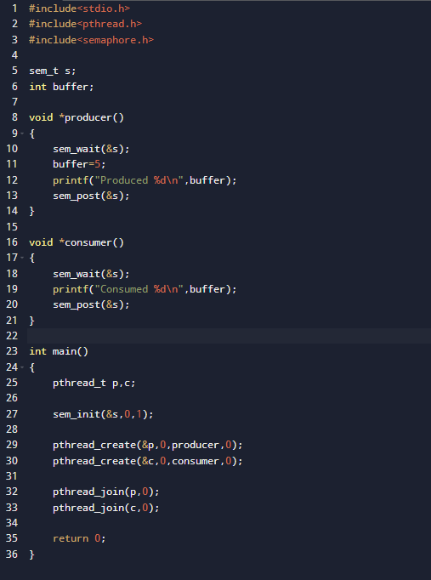

Output:
